Inner Join

Definition
# Source: AI Source: Provided by: [Data Path: Persons Table -> ID Column: 1, Name_En Column: Motasem Essam] -> From: [Chatgpt (GPT‑5 Mini)] on [12/10/2025]
Inner Join is a data operation used to combine two datasets by keeping only the rows that have matching values in both tables based on a common key. Rows that do not have matching keys are excluded from the result.

Key Idea
# Source: AI Source: Provided by: [Data Path: Persons Table -> ID Column: 1, Name_En Column: Motasem Essam] -> From: [Chatgpt (GPT‑5 Mini)] on [12/10/2025]
Inner Join returns the intersection of two datasets based on the specified key column(s). Only records that appear in both tables are included in the merged result.

How It Works
# Source: AI Source: Provided by: [Data Path: Persons Table -> ID Column: 1, Name_En Column: Motasem Essam] -> From: [Chatgpt (GPT‑5 Mini)] on [12/10/2025]
- Identify the common key column between the two datasets.
- Compare the values in the key column of both tables.
- Keep only rows where the key exists in both datasets.

Example
# Source: AI Source: Provided by: [Data Path: Persons Table -> ID Column: 1, Name_En Column: Motasem Essam] -> From: [Chatgpt (GPT‑5 Mini)] on [12/10/2025]
Dataset A – Customers
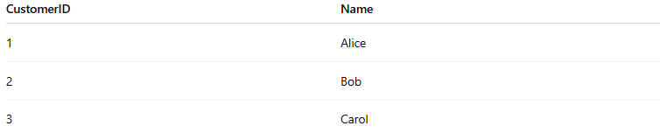
CustomerID | Name
1 | Alice
2 | Bob
3 | Carol
Dataset B – Orders
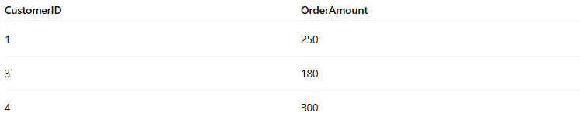
CustomerID | OrderAmount
1 | 250
3 | 180
4 | 300
Inner Join on CustomerID
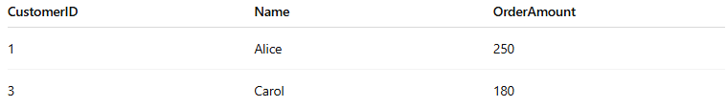
CustomerID | Name | OrderAmount
1 | Alice | 250
3 | Carol | 180
- Customer 2 is removed because there is no matching order.
- Customer 4 is removed because there is no matching customer record.

Applications
# Source: AI Source: Provided by: [Data Path: Persons Table -> ID Column: 1, Name_En Column: Motasem Essam] -> From: [Chatgpt (GPT‑5 Mini)] on [12/10/2025]
- Combining customer and order data
- Matching student records with exam results
- Integrating datasets with shared identifiers

Advantages
# Source: AI Source: Provided by: [Data Path: Persons Table -> ID Column: 1, Name_En Column: Motasem Essam] -> From: [Chatgpt (GPT‑5 Mini)] on [12/10/2025]
- Keeps only relevant matched data
- Reduces irrelevant or unmatched rows
- Useful for relational database queries

Disadvantages
# Source: AI Source: Provided by: [Data Path: Persons Table -> ID Column: 1, Name_En Column: Motasem Essam] -> From: [Chatgpt (GPT‑5 Mini)] on [12/10/2025]
- Unmatched data is lost
- If keys are missing or inconsistent, important records may be excluded

